Journal Article Writing Workshop (Speaker: Dr. Ted Fowler, Co-director of the Southwest Hub of the Ohio STEM Learning Network (OSLN); Three Workshop Sessions: June 29, 2015, 10:30 am–12:00 pm; July 8, 2015, 9:00 am–10:45 pm; and July 21, 2015, 10:45 am–12:00 pm)
Dr. Fowler is the Co-director of the Southwest Hub of the Ohio STEM Learning Network (OSLN). In that position he works to promote STEM education in southwest Ohio and seeks grant funding for teacher professional development and research in STEM education. Dr. Fowler started his career as a physics and chemistry teacher. After earning graduate degrees at Rensselaer Polytechnic Institute, Harvard University, and the University of Houston he came to the UC and taught instructional methods and curriculum development courses and served as programs coordinator while developing working relationships with many school districts, informal science education providers, and county education agencies. Dr. Fowler worked with the College of Engineering in a series of collaborations to develop instructional skills of engineers and science faculty and introduce engineering graduate students as an instructional resource into high school classrooms as well as involve science and math teachers in on-campus engineering research experiences. He worked several years as a curriculum developer and researcher at the Centers for Disease Control and Prevention, National Institute for Occupational Safety and Health (NIOSH). Most recently he has worked to deliver embedded professional development in Mt. Healthy Schools and Cincinnati Public Schools, providing workshops and training for science teachers. Dr. Fowler is now focused on working with industry to establish real-life applications for science and mathematics for students and teachers.
Dr. Fowler began the session explaining the importance of a journal article. He emphasized how journal articles are an important resource for teachers to share their knowledge and experiences. Next he discussed the 3 different types of publications that teachers could pursue to submit journal articles. The first type is an informal publication such as a local newspaper, a school community newsletter, or an alumni newsletter. Digital articles could also be submitted to each of these type of publications. Writing for a local audience can be a great public relations move on the part of the teacher. School administrations appreciate teachers who showcase what is happening in their classrooms. The second type is a statewide/national publication such as Mathematics Teacher or Science Teacher. This type of journal targets readers with similar teaching backgrounds. Articles submitted for publication are reviewed by peer teachers. Once an article is written a teacher could also present the information at a local/state teacher conference. The third type of publication is a professional journal in which articles are critically reviewed. Articles submitted to these type of journals are reporting on research that has taken place within a classroom.
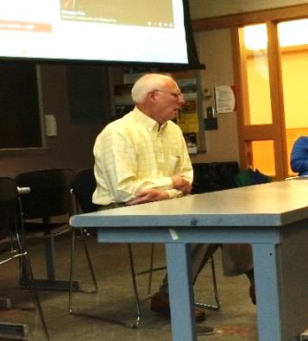
Figure 1: Dr. Fowler Speaking to the RET Program
Next Dr. Fowler distributed two articles that were written for local publications. The first article was about an after school program that involved a bike club. The club is sponsored by Time Warner Cable and the article was written by one of their public relations employees. The second article was written for the Deer Park community. The purpose of this article was to showcase their eMentoring/Mentor Place program with the Greater Cincinnati STEM Collaborative. After reading through these articles the group discussed the different elements involved with writing for a local publication. Each article began with an introduction of the program being showcased. The articles also included quotes from people and endorsements from local organizations. The tone of each article was very positive and its intent was to impress the local communities of the activities happening in their schools. Dr. Fowler emphasized how writing for a local group is a good first step to journal writing.
The next set of articles Dr. Fowler distributed were taken from two professional journals, Mathematics Teaching in the Middle School and The Science Teacher. After reading through the articles the group compared the writing styles of these articles with the articles first distributed. One of the first observations was that these journal articles were mainly written for teachers in a specific field. The article from The Science Teacher was written by a high school science teacher intended for other science teachers. The article, The Friendship Detector, explained how electrical circuits can be used in the decision making process. The article contained lesson plans, pictures, scoring rubrics, student reactions, and suggestions for differentiation. Both professional journal articles gave a detailed account of the lesson being featured.
The last article Dr. Fowler presented was a research article. This article was quite extensive and written on a much higher level. A lot of research with data and statistics were presented in the article and the intended reading audience was probably post-graduate professionals. Dr. Fowler asked the group to bring an example of a journal article of their interest to the next session. He also asked the RET participants to create an outline for an article they would like to write.
Dr. Fowler’s second presentation began with the group sharing their journal articles. The group discussed the different types of journals they researched; mostly in their given fields of teaching. Dr. Fowler emphasized how each publication has specific guidelines for writing; though each will request a list of national standards, such as NGSS or Common Core, that are being addressed in the writing. Another important factor is that these articles cannot be fully written until the lesson has been implemented in the classroom. After the group shared their articles, time was given for RET participants to email Dr. Fowler their outlines/drafts for a journal article.
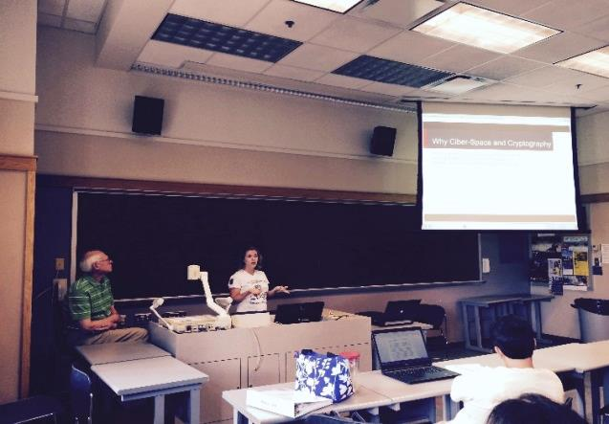
Figure 2: RET Teacher Presentation a Draft Article
During his final presentation, Dr. Fowler reminded the group to leave space within their articles for writing about what worked with their students when the lesson was implemented and about how the lesson was evaluated. He noted how some articles include an abstract which then could be submitted for local publications. Next Dr. Fowler asked a few of the RET participants to share their outlines/drafts with the entire group. The first presenter shared a power point outline for unit that could be presented at a conference. The presentation carefully described how the engineering design process was imbedded into the Challenge Based Learning Unit. Each piece of the process was assigned a slide showing how it was being implemented into the unit. The second presenter shared the beginning of an article being written for Mathematics Teacher. The article first gives an introduction of the work being completed this summer in the RET program and information on the engineering design process. Next was an overview of the research completed this summer and how it ties into the unit being developed for the classroom. An outline for the remaining pieces of the article was also shared. In the end Dr. Fowler encouraged the group to contact him for assistance in writing their articles.

